Civil war in Liberia

UNSC Resolution: | 950
Date of adoption: | 21-Oct-1994
Operative paragraph: | 5
Demand number: | 950,0511

Sarah-Myriam Martin-Brûlé

Wording of demand

seek political accommodation and national reconciliation and work with the Chairman of ECOWAS and with the Special Representative of the Secretary-General to achieve a durable settlement

List of addressees of the demand

Government of Liberia

Short-term compliance

Description of the addressee(s)’ conduct

“The Accra agreement had called for a cease-fire by 28 December 1994 and the installation of a new Council of State by 11 January 1995. Neither event happened. The Liberian parties met in Accra under ECOWAS auspices in early January 1995 in a bid to agree on the composition and chairmanship of the Council of State. But the talks deadlocked. On 24 January, an ECOWAS minisummit was hosted again in Accra by the indefatigable ECOWAS chairman, Jerry Rawlings- the Pied Piper of Accra, who continued to play diplomatic tunes to which Liberia’s warlords often refused to dance.“ (Adebajo 2002: 165)

Adebajo, Adekeye. 2002. Liberia’s Civil war: Nigeria, ECOMOG and Regional Security in West Africa. A project for the International Peace Academy. Lynne Rienner Publisher

The Security Council extended the mandate of UNOMIL until 13 April by its resolution 972 (1995) of 13 January. In accordance with the timetable set out in the Accra agreement, the Liberian parties were to have nominated a new five-member Council of State by 11 January 1995. However, when they met in Accra under the auspices of ECOWAS on 9 January, they were unable to reach agreement on the composition and chairmanship of the Council. The main bottleneck was the inability of AFL and Coalition forces (ULIMO-J, LDF, LPC and CRC-NPFL) to reach agreement on their joint nominee. Nominees from the other parties included Mr. Charles Taylor, President of NPFL; Mr. Alhaji Kromah, Chairman of ULIMO-K; and Mr. Oscar Quiah, representative of LNC.
UNOMIL, Liberia, Background
http://www.un.org/Depts/dpko/dpko/co_mission/unomilFT.htm#DECEMBER

“The representative of Liberia stated that, while it was disappointing that talks in
Accra among the faction leaders, which should have culminated in the establishment of a
new Council of State, appeared to have ended in a stalemate, his delegation was hopeful
that that was only a temporary setback.”
Repertoire of the Practice of the Security Council, Chapter 8, “The Situation in Liberia’
http://www.un.org/fr/sc/repertoire/93-95/CHAPTER%208/AFRICA/item%2005-%20Liberia.pdf

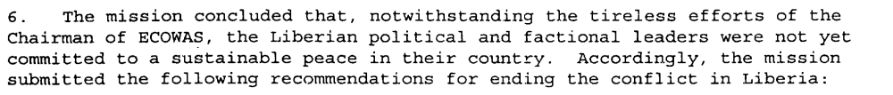
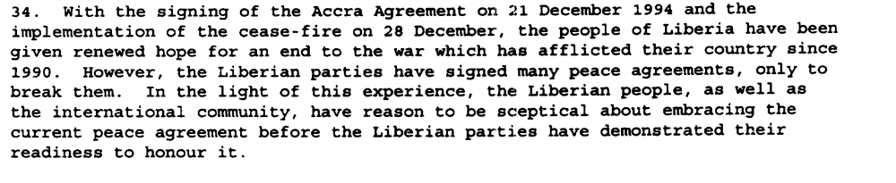
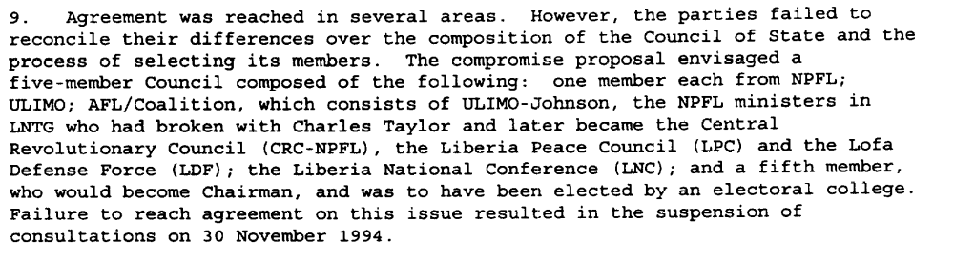
Eight Progress Report of the Secretary-General on the United Nations Observer Mission in Liberia, S/1995/9, 6 January 1995

Assessment

Short-term compliance
No or marginal compliance (1) | X Medium low compliance (2) | Medium high compliance (3) | Full or almost full compliance (4)

Considerations underlying the assessment

The demand addressees did seek political accommodation and national reconciliation and did work with the Chairman of ECOWAS and with the Special Representative of the Secretary-General to achieve a durable settlement yet only to a limited extent. Their will and efforts were insufficient to reach such political accommodation and national reconciliation. Hence their compliance can only be related to those aspects of the demand which were of relatively low significance to the achievement of the objectives of the demand (strong and determined efforts to political accommodation, national reconciliation and durable peace settlement).

Medium-term compliance

Description of the addressee(s)’ conduct

“In the meantime, the Third Meeting of Heads of State and Government of the ECOWAS Committee of Nine on Liberia was held at Abuja from 17 to 20 May 1995. The meeting was also attended by representatives of the United Nations, OAU and the United States. The following Liberian parties sent their delegations: AFL, LNC, LPC, NPFL, CRC-NPFL, ULIMO-K, and ULIMO-J. Mr. Kpomakpor, the Chairman of the Council of State, also participated in the meeting. Delegations of all the Liberian factions except NPFL were headed by their respective leaders.”
(...)
“Despite four days of discussions and the emergence of a substantial measure of agreement on nearly all the outstanding issues, the Liberian parties were unable to reach a final agreement on the composition of the Council of State.”
(...)
“After four days of intensive discussions, the Abuja talks culminated on 19 August 1995 in the signing by the Liberian parties of an agreement, amending and supplementing the Cotonou and Akosombo accords, as subsequently clarified by the Accra agreements. In accordance with provisions of the Abuja Agreement, a comprehensive ceasefire was established on 26 August at midnight and a new six-member Council was installed on 1 September, one day ahead of schedule. The Council comprised Mr. Wilton Sankawolo as its Chairman; Dr. George Boley, representing the coalition of LPC, CRC-NPFL and LDF; Mr. Alhaji Kromah of ULIMO; Mr. Oscar Quiah of LNC; Chief Tamba Taylor; and Mr. Charles Taylor of NPFL. AFL was given the defence portfolio, while General Roosevelt Johnson's wing of ULIMO (ULIMO-J) was given a number of ministerial posts. The new Council of State would remain in power for one year, until the holding of elections on 20 August 1996. The Agreement also included a schedule of implementation and a formula for the distribution of government posts.”
(...)
“An ECOWAS delegation visited Liberia from 25 to 27 August to assess the situation on the ground and confirmed that the factions had sent instructions to their forces to lay down arms and observe the ceasefire. In the meantime, UNOMIL and ECOMOG began active preparations for the implementation of the Agreement. The Ceasefire Violations Committee, chaired by UNOMIL and consisting of ECOMOG and representatives of the transitional government and the factions, met in the beginning of September to review with the factions plans for monitoring the ceasefire and the implementation of the other provisions of the Agreement, including disarmament and demobilization. A Disarmament Committee, chaired by ECOMOG and comprising UNOMIL, the transitional government and representatives of the armed factions, with the participation of the International Committee of the Red Cross (ICRC), was established to draw up plans for the disengagement of forces, disarmament and the exchange of prisoners of war. The international community was urgently requested to provide support for ECOMOG as well as for the disarmament, demobilization and reintegration of combatants”
(...)
“By the end of 1995, following some initial progress in the implementation of the peace agreements and improvement in the security and humanitarian conditions in the country, the situation in Liberia began to take another turn for the worse. The implementation of the Abuja Agreement was behind schedule. The critical aspects of the Agreement, disarmament and demobilization, did not begin at the time foreseen. There were serious violations of the ceasefire. These violations included intermittent fighting between Alhaji Kromah's forces (ULIMO-K) and Roosevelt Johnson's forces (ULIMO-J). Fighting also occurred between LPC and NPFL and between NPFL and ULIMO-K. There were also delays in deploying ECOMOG personnel and equipment throughout the country. At the end of December 1995, heavy fighting broke out at Tubmanburg as a result of attacks on ECOMOG by ULIMO-J troops. Casualties were suffered by the combatants and by the civilian population.”
(...)
“In this volatile atmosphere, following confrontations between rival groups within ULIMO-J, the transitional government, on 23 March, issued a warrant for the arrest of General Roosevelt Johnson, accusing him of murder. On 6 April, the Rapid Reaction Unit of the national police, backed up by the forces of NPFL and ULIMO-K, attempted to arrest him forcibly. They were attacked by General Johnson's forces, supported by fighters from AFL.”
(...)
“The fighting was accompanied by the complete breakdown of law and order in Monrovia. Fighters from all factions systematically looted the commercial district as well as United Nations offices and warehouses. Houses were broken into, buildings were set on fire and vehicles were commandeered.”
(...)
“Despite efforts to establish a cohesive Council of State, the faction leaders on the Council remained deeply mistrustful of one another. The climate worsened on 31 October when, in an apparent assassination attempt on Councilman Charles Taylor, five persons, including a close personal aide to Mr. Taylor, were killed at the Executive Mansion. As a result of the deep divisions which resurfaced within the Council of State following this incident, the Council did not meet again until 16 January 1997. A joint investigation of the incident was undertaken by the Ministry of Justice, UNOMIL and ECOMOG.”
(...)
“In its resolution 1071 (1996) of 30 August, the Security Council had requested the Secretary-General to submit proposals for assistance which UNOMIL or other United Nations agencies could contribute in support of the Liberian peace process. With this in mind, the Secretary-General dispatched a technical team to Liberia, which was led by his Deputy Military Adviser.”
(....)
“ On 8 November 1996, the Council addressed a letter to the Secretary-General welcoming his proposals. The members of the Council were concerned, however, that conditions in Liberia were not right for their implementation at that time. It was the Council's understanding that the Secretary-General would not deploy the additional personnel and logistic resources unless the factions took the concrete steps required to fulfil their commitments under the revised timetable of the Abuja Agreement.
UNOMIL, Liberia, Background
http://www.un.org/Depts/dpko/dpko/co_mission/unomilFT.htm#DECEMBER

Assessment

Medium-term compliance
No or marginal compliance (1) | X Medium low compliance (2) | Medium high compliance (3) | Full or almost full compliance (4)

Considerations underlying the assessment

The demand addressees did seek political accommodation and national reconciliation and did work with the Chairman of ECOWAS and with the Special Representative of the Secretary-General to achieve a durable settlement yet only to a limited extent. Their will and efforts were insufficient to reach such political accommodation and national reconciliation. Hence their compliance can only be related to those aspects of the demand which were of relatively low significance to the achievement of the objectives of the demand (strong and determined efforts to political accommodation, national reconciliation and durable peace settlement).

Depth of demand

Assessment

Level of depth of demand
Low depth of demand (1) | Medium depth of demand (2) | High depth of demand (3)

Considerations underlying the assessment

Compliance with this demand made it significantly more difficult for the demand addressees to gain power.

“The warlords insisted on exchanging disarmament for political power and attempted to use Ghana against Nigeria to promote their own interest. The NPFL split into two factions while Liberia’s smaller factions formed a loose anti-NPFL alliance to promote their military and diplomatic goals. The unwieldy alliance successfully won a place at the negotiating table by capturing territory largely from NPFL. However, it lacked the cohesion to champion a common political agenda and further complicated ECOWAS peacemaking task. (Adebajo 2002: 156).”

Adebajo, Adekeye. 2002. Liberia’s Civil war: Nigeria, ECOMOG and Regional Security in West Africa. A project for the International Peace Academy. Lynne Rienner Publisher

Level of confidence about coding decisions

Level of confidence about coding decision
Extremely high | X High | Moderate

Comments to IPI (if any)

